TASK ON RDS
- Create MariaDB DB on EC2.
Objective:
To install, configure, and secure a MariaDB database server on an AWS EC2 instance, enabling applications to store and retrieve data efficiently.
Purpose:
- Store application data in a relational database.
- Support web applications such as WordPress, Joomla, Drupal, and custom applications.
- Provide secure and centralized data management.
- Learn database administration on AWS EC2.
- Enable client-server communication for applications.
Prerequisites
AWS Account
Running EC2 Instance (Amazon Linux 2/2023)
Security Group configured
SSH access to EC2
Steps:
  - Created a instance My-ec2-maria-DB with existing key_pair, MY-VPC-ASG, subnet, My-Pub-Subnet-ASG enabling the public IP, selecting the existing security groups.
  - Connect to the ec2 instance from ssh using the public IPV4
  - Switch to root user, sudo su - & install the mariadb105-server
  - Now enable and start the mariadb server
  - We need to set the environment variables as
    - DBName=ec2db
    - DBPassword=admin123456
    - DBRootPassword=admin123456
    - DBUser=ec2dbuser
  - To set up database on ec2 instance will run the below commands
•echo "CREATE DATABASE ${DBName};" >> /tmp/db.setup

•echo "CREATE USER '${DBUser}' IDENTIFIED BY '${DBPassword}';" >> /tmp/db.setup
•echo "GRANT ALL PRIVILEGES ON ‘${DBName}’. TO '${DBUser}'@'%';" >> /tmp/db.setup
•echo "FLUSH PRIVILEGES;" >> /tmp/db.setup
mysqladmin -u root password "${DBRootPassword}"
  - Use mysql -u root --password="${DBRootPassword}" to login and USE ec2db to connect to db which we created.

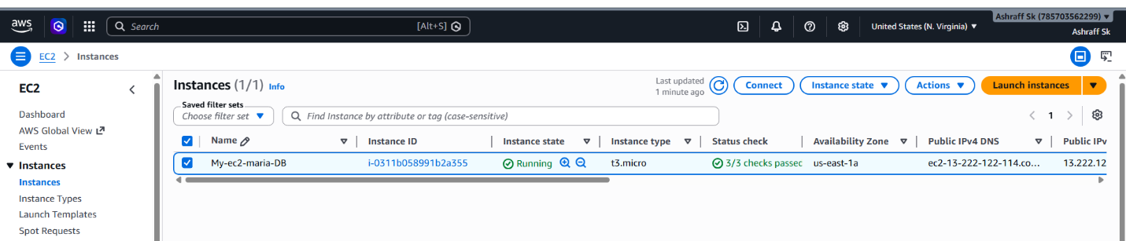
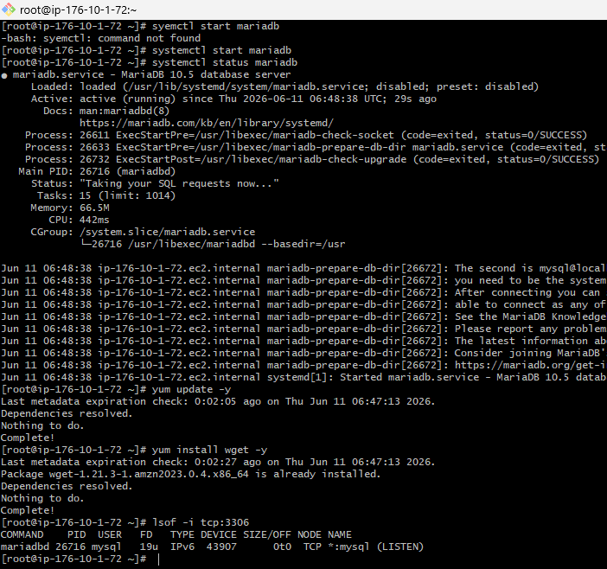
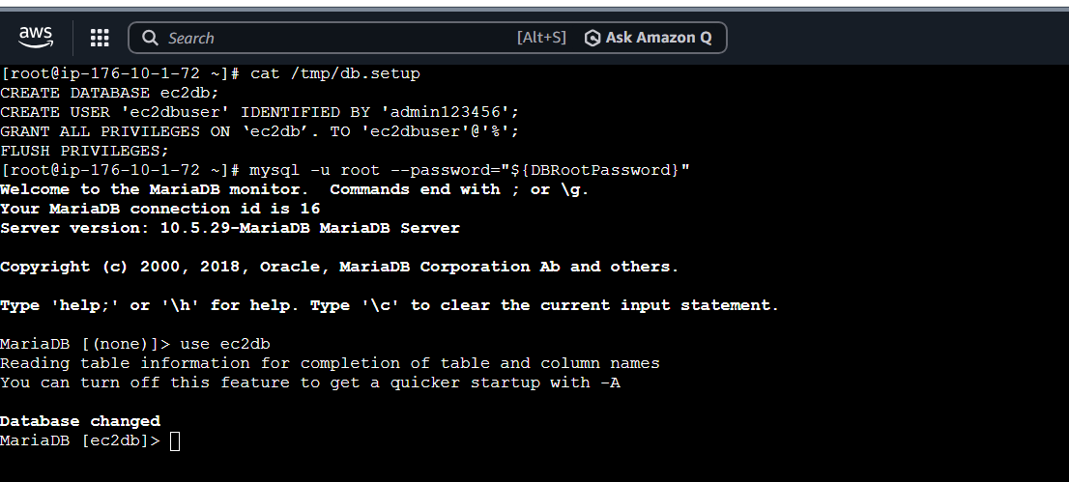

- Insert some dummy data.
Objective:
To populate a MariaDB database running on an EC2 instance with sample records for testing, development, database connectivity validation, query execution, and application integration.
Purpose:
Verify that the MariaDB server is functioning correctly.
Test database connectivity from applications and clients.
Practice SQL operations such as INSERT, SELECT, UPDATE, and DELETE.
Validate backup and restore procedures using sample data.
Simulate real-world data for development and learning purposes.
Ensure tables and database permissions are configured properly.
Steps:
  - Connect to ec2 instance, My-ec2-maria-DB with ssh
  - To connect to the mariadb use mysql -u root --password="${DBRootPassword}"
  - Run the below commands to create a table & insert some data
    - USE ec2db;
    - CREATE TABLE table1 (id INT, name VARCHAR(45));
    - INSERT INTO table1 VALUES(1, 'Virat'), (2, 'Sachin'), (3, 'Dhoni'), (4, 'ABD');
    - SELECT * FROM table1;

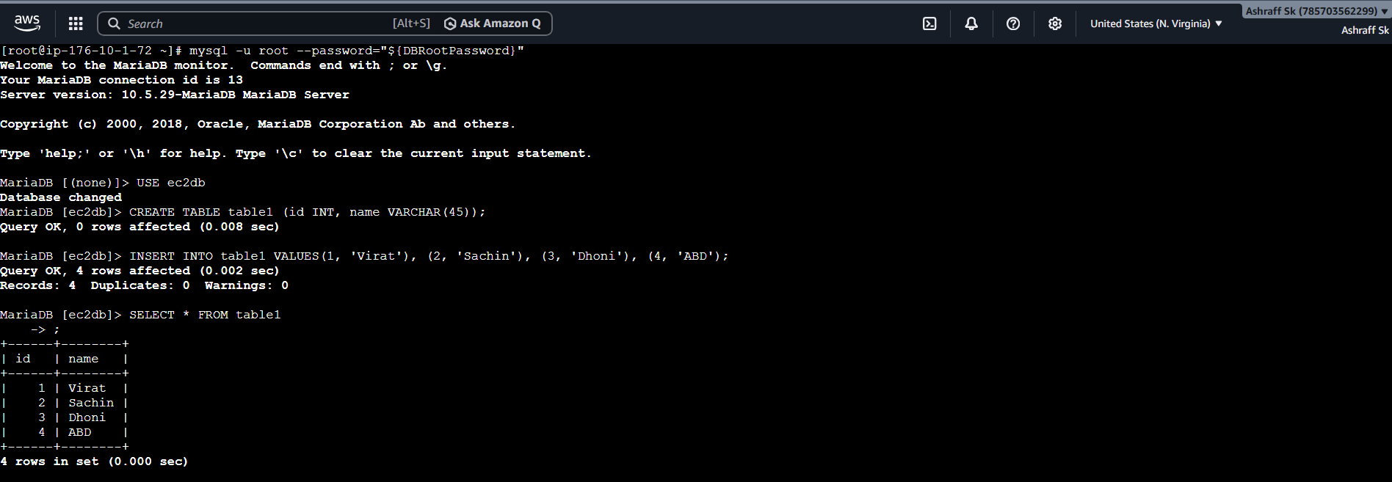

- Take the backup of dummy data on EC2.
Objective
To create a backup of a MariaDB database running on an EC2 instance using mysqldump, ensuring that the database can be restored in case of accidental deletion, corruption, or system failure.
Purpose:
- Protect critical database information from data loss.
- Enable disaster recovery and business continuity.
- Create restore points before upgrades or changes.
- Support migration of databases between servers.
- Maintain compliance with backup and recovery policies.
- Validate backup and restore procedures.
Prerequisites:
MariaDB installed and running on EC2.
Database contains sample/dummy data.
Access to MariaDB root or backup user.
Sufficient disk space for backup files.
Steps:
  - Connect to ec2 instance, My-ec2-maria-DB with ssh
  - Switch to root user & create a database, ec2db
  - Insert some data into the ec2db
  - Exit from mariadb and switch to root user of ec2 instance
  - Use mysqldump -u root -p ec2db > ec2db_backup.sql
  - Run ls -lh command to check the backup created file


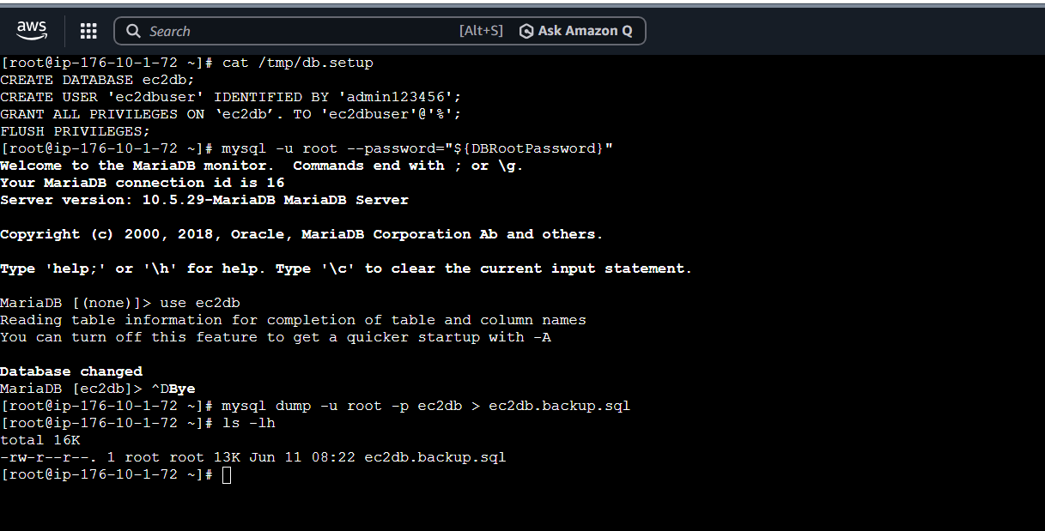

- Launch MariaDB RDS instance.
Objective
To create and configure an AWS RDS MariaDB instance that provides a fully managed relational database service, eliminating the need to manage database server infrastructure manually.
Purpose:
- Deploy a managed MariaDB database in AWS.
- Reduce database administration overhead.
- Enable automatic backups and recovery.
- Improve availability and scalability.
- Secure database access within a VPC.
- Support web and enterprise applications
Prerequisites:
AWS Account
Existing VPC
At least one EC2 instance (optional for testing)
Security Group allowing database access
IAM permissions to create RDS resources.
Steps:
- Launched aws console and login with your credentials.
- Go to RDS service.
- Click on Create database.
- Select full configuration.
- Select MariaDB.
- Select Full configuration under Choose a database creation method.
- Select vpc that has more than 2 available zones for subnets
- Then create database
- Make sure the public access is on
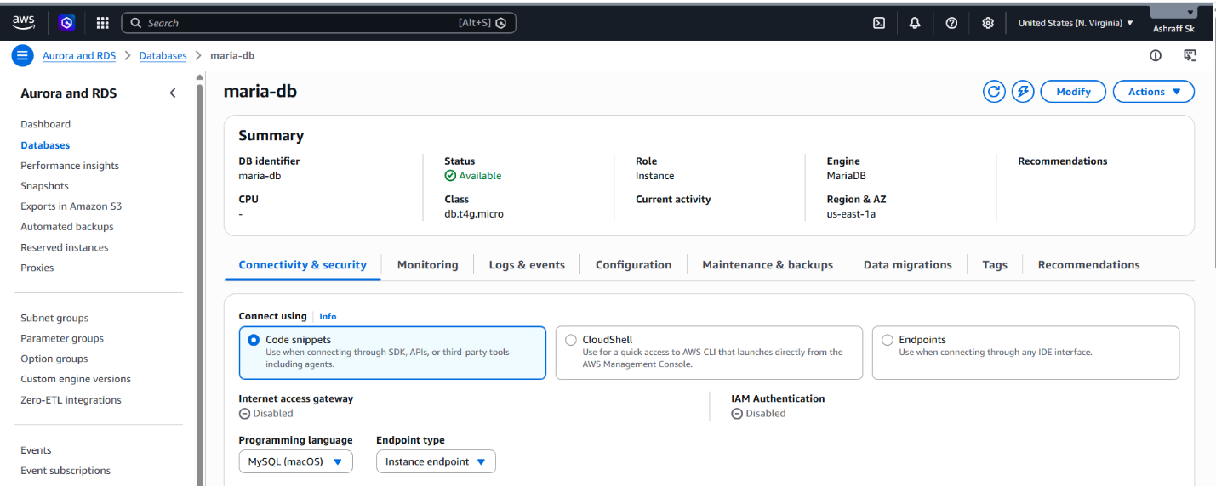
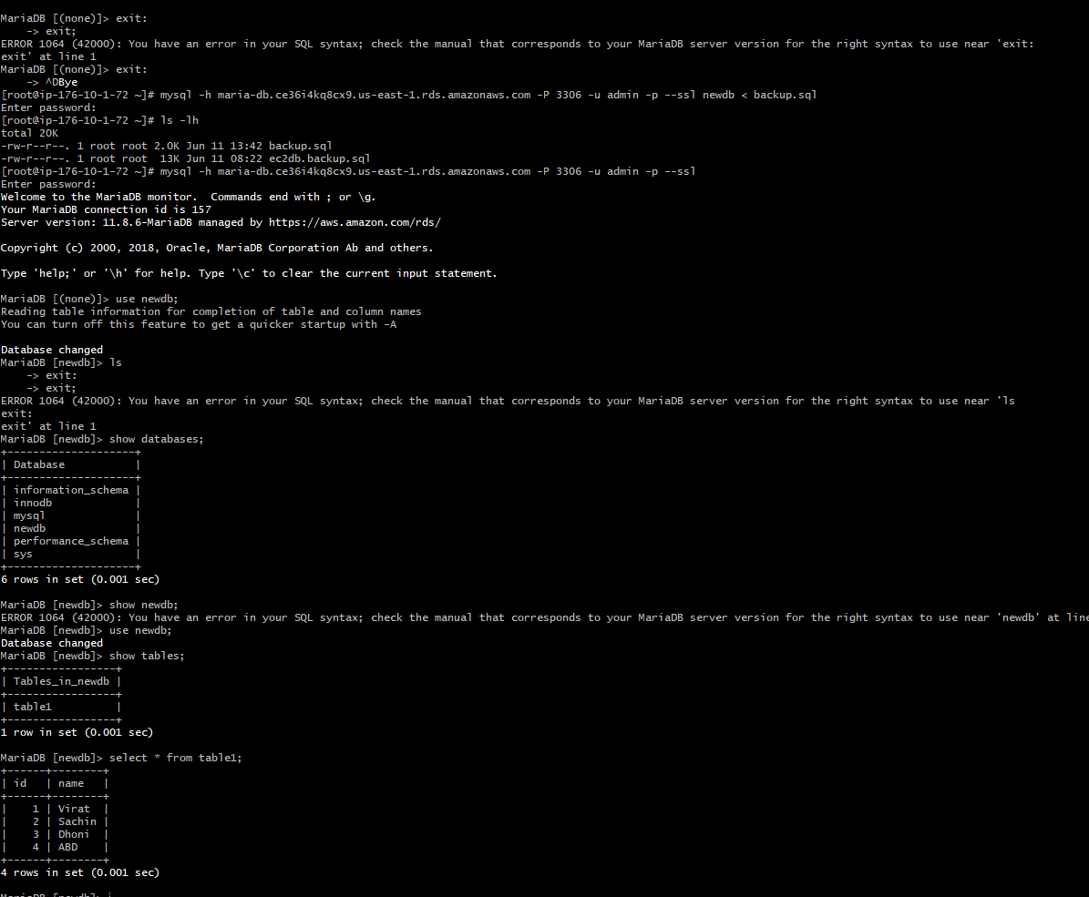
- Migrate database from EC2 to RDS.
Objective:
To migrate an existing MariaDB database from an EC2 instance to an AWS RDS MariaDB instance, ensuring data availability, improved manageability, automated backups, and high availability
Purpose:
- Move from a self-managed database on EC2 to a fully managed AWS RDS service.
- Reduce database administration tasks.
- Enable automated backups and recovery.
- Improve database security and availability.
- Simplify scaling and maintenance.
Steps:
- Get the dump of your existing DB on EC2
- mysqldump -u root -p database_name > file_name.sql
- Created in task 4
- Migrate the DB dump that you have taken in step 1 to RDS
- mysql -h <endpoint> -P 3306 -u admin -p newdb < backup.sql --ssl --> run on EC2
- Connect to your RDS DB instance
- mysql -h <endpoint> -u admin –p --ssl
- Switch to the database and verify the details.
- USE newdb;
- SELECT * FROM table1;



- Install MySQL DB on EC2.

Objective:
Install MySQL client/software on the EC2 instance.

Outcome:
EC2 should be able to run MySQL commands and connect to a MySQL database.
Steps:
- sudo yum update -y
- sudo yum install mariadb105-server -y
- Then use the below commands to install mysql in instance
- sudo yum update -y
- Systemctl start mariadb
- Then install mysql
- Use---
- sudo mysql_secure_installation
- Then give the speciffic permissions
- Complete the setup
- Now mysql has been installed in ec2
- To login use ---- mysql -u root -p or mysql -u root
- We have entered the mysql database
- We can check the mysql –version if mysql is installed or not

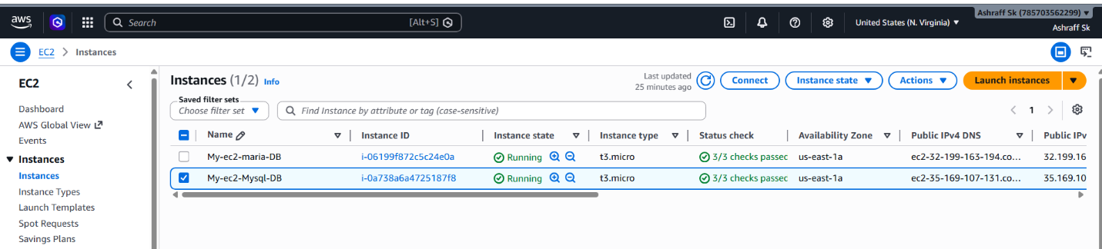
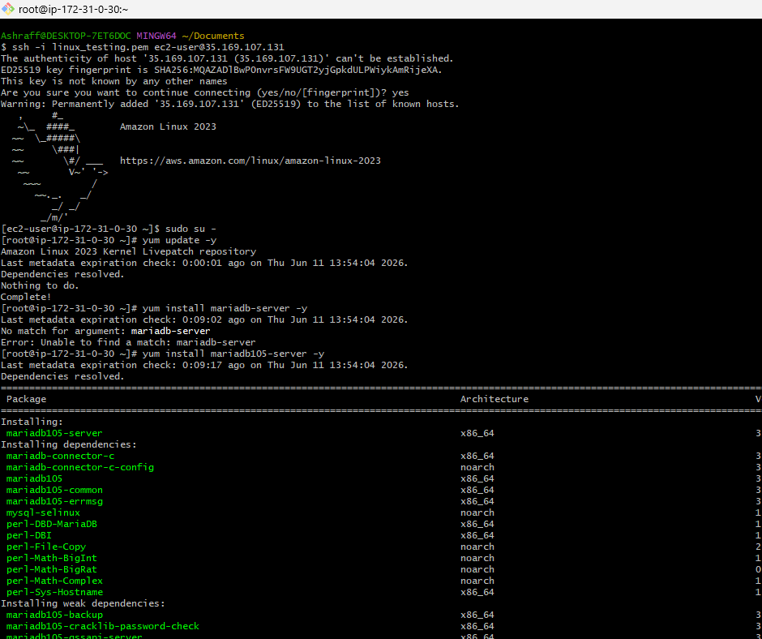
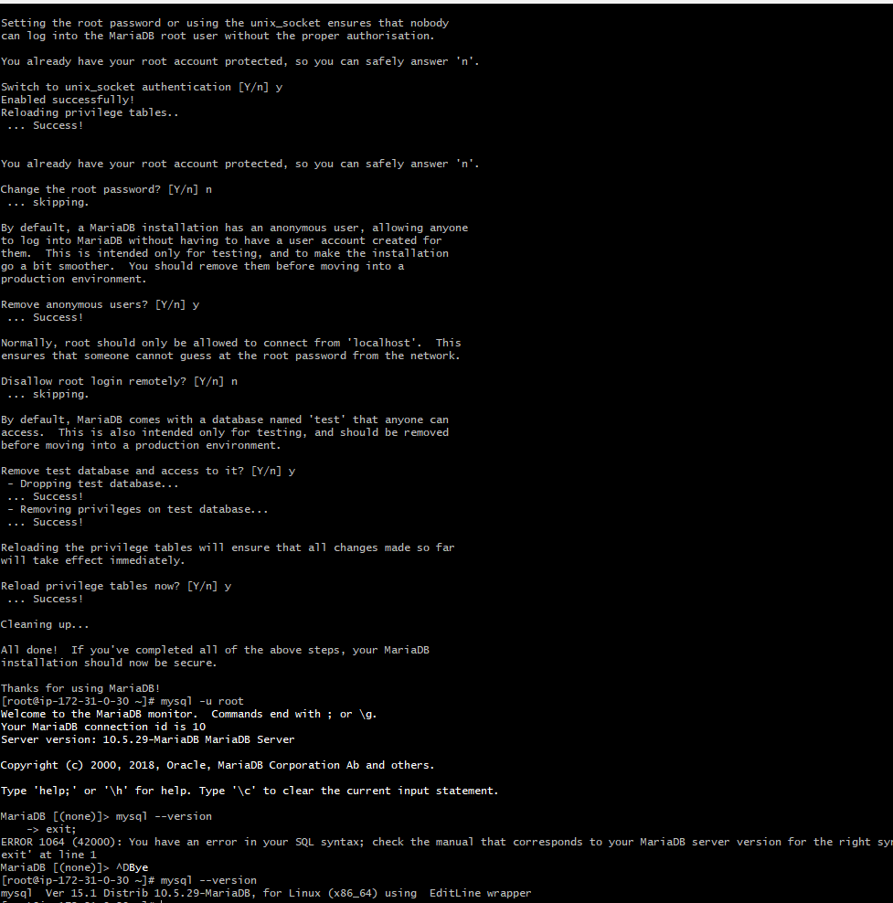
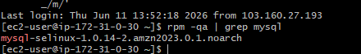

- Launch MySQL RDS image.
Objective:
Configure the MariaDB RDS instance to use Multi-AZ deployment for high availability.

Steps:
- Creating a new RD database With my sql image
- Give master username that can be used to login to our mysql rds
- We can either connect to the instance now or later
- To launch an RDS database it should have min 2 AZ’s
- I have launched an RDS WITH MYSQL AS IMAGE
- Note----if instance vpc and RDS VPC is different we need to first make VPC PEERING CONNECTION
- Then we can connect to both
- If same vpc we do not need vpc peering
- This will be applicable when I launch my RDS on private subnet then we need peering
- if launched on public then no need to give peering because the database is exposed to public
- I connected to rds from ec2 without peering connection as my database is in public subnet that has internet access 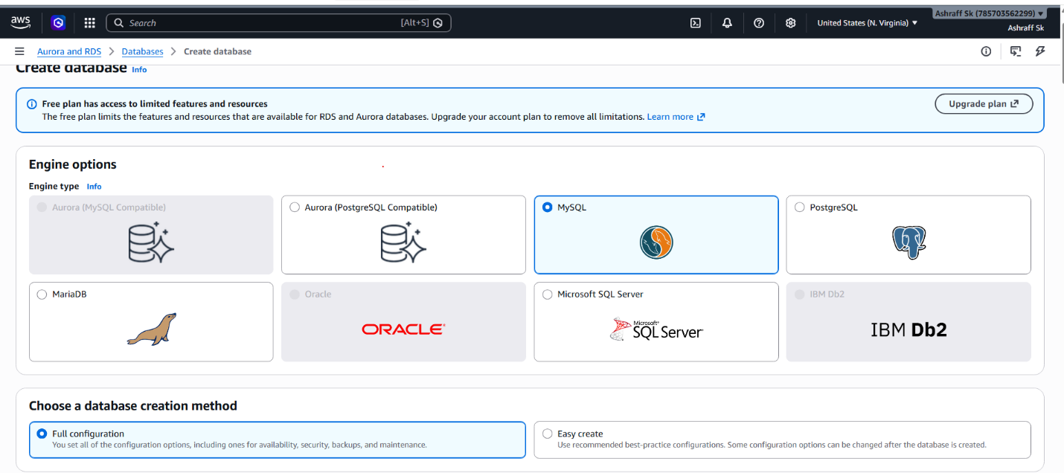
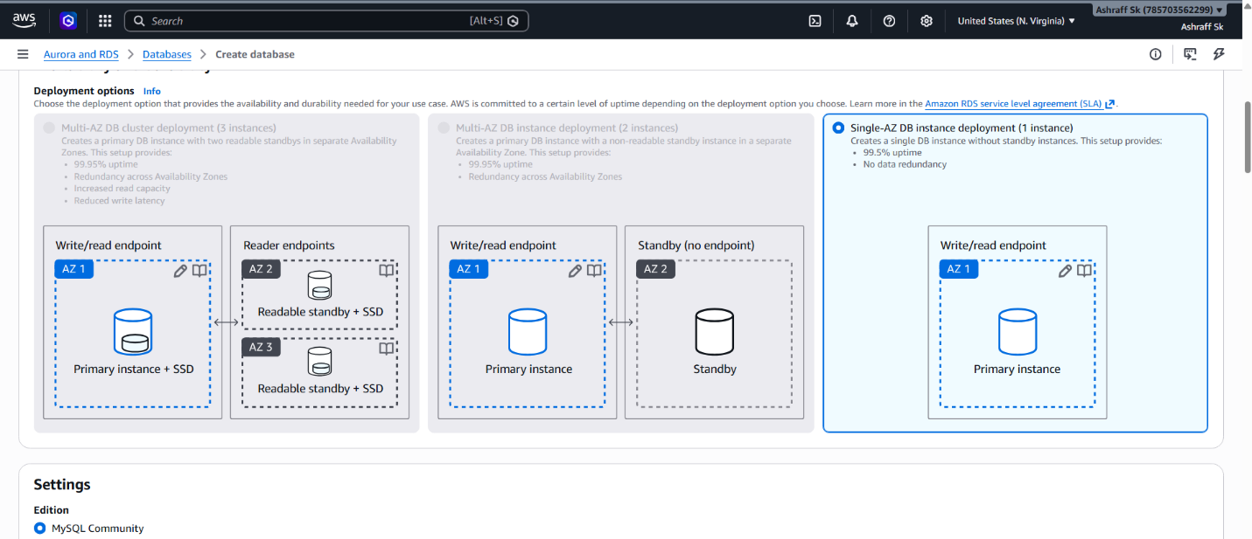

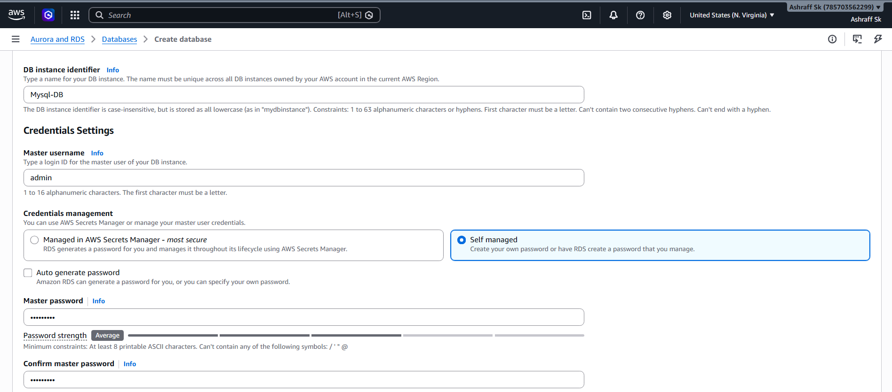
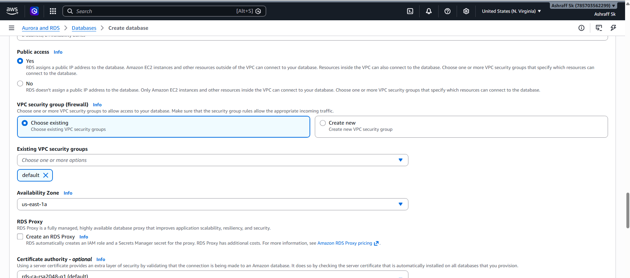

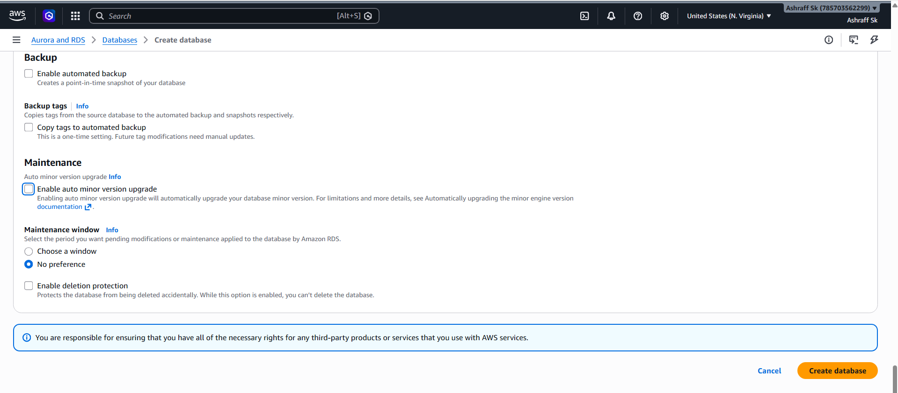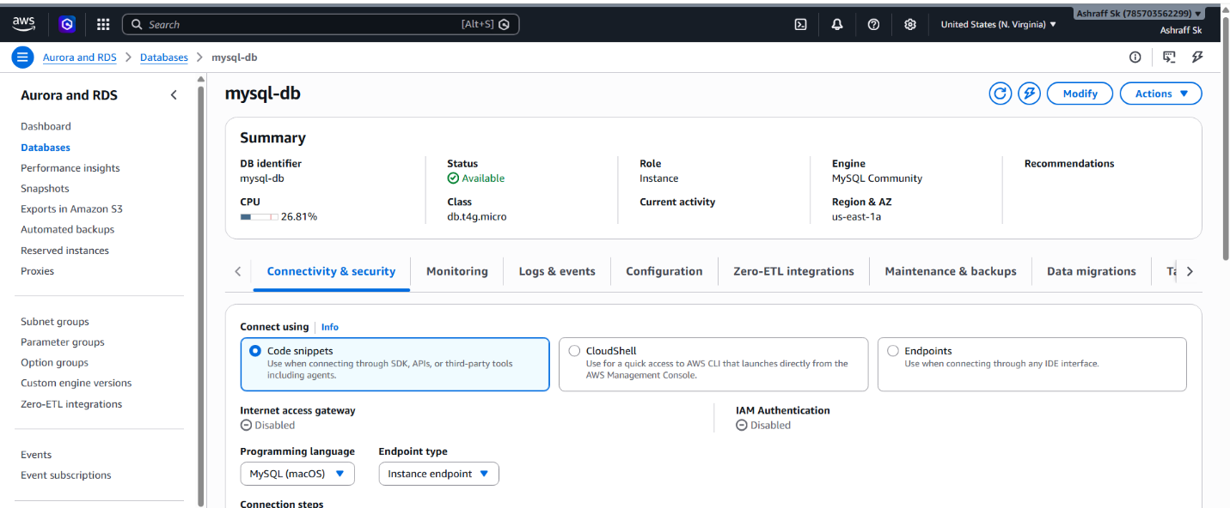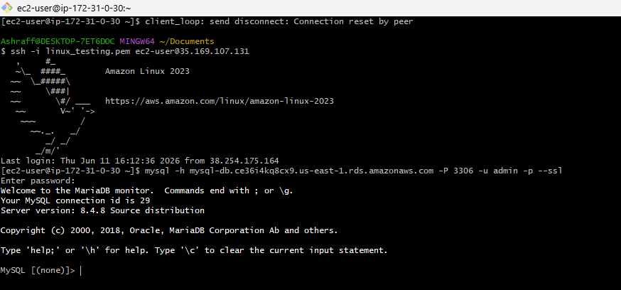
- Configure Multi-AZ.
Objective:
Configure the MariaDB RDS instance to use Multi-AZ deployment for high availability.
Purpose:
To improve database availability and fault tolerance by maintaining a synchronous standby replica in another availability zone.

A Multi-AZ acts as replication database for our primary database
The replicated database will be in another available zone
Which is why we call it as multi-AZ
The replicated database in other zone is always on standby it will be used when the primary database AZ is failed/down or under maintenance then the standy database is accessed present in the other availability zone of same region
To configure multi-az we can modify the maria db enabling multi-AZ deployment option in Availability & durability
Use- case:
Minimize latency spikes during system backups.

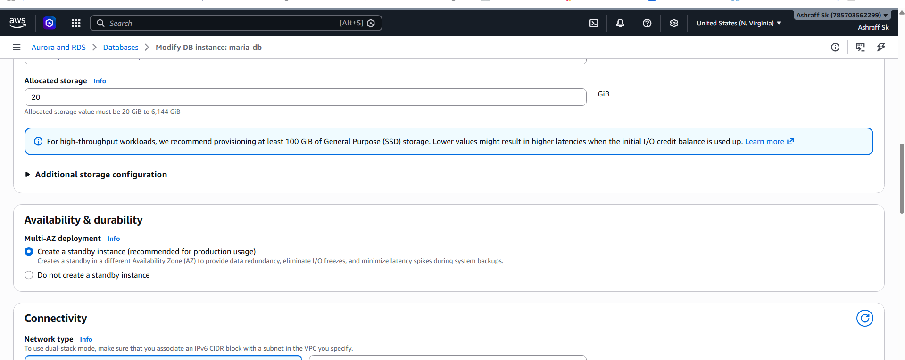

- Take backup of DB and restore the DB.

Objective
To Create a backup (snapshot) of the RDS database & restore a new database from that backup.
Steps:
- First I will create a backup of database
- Then after creating the backup using the backup I will be restoring the DB
- To create a backup I will use snapshot of my present mysql image RDS
- First I will create snapshot
- A new snapshot has been created for MYSQL image of RDS has been
created
- Using this snapshot I will restore my database
- Click on restore snapshot
- After configuration click on restore DB instance
- New database has been created using the backup of old database
- And the endpoint will be changed for restored database
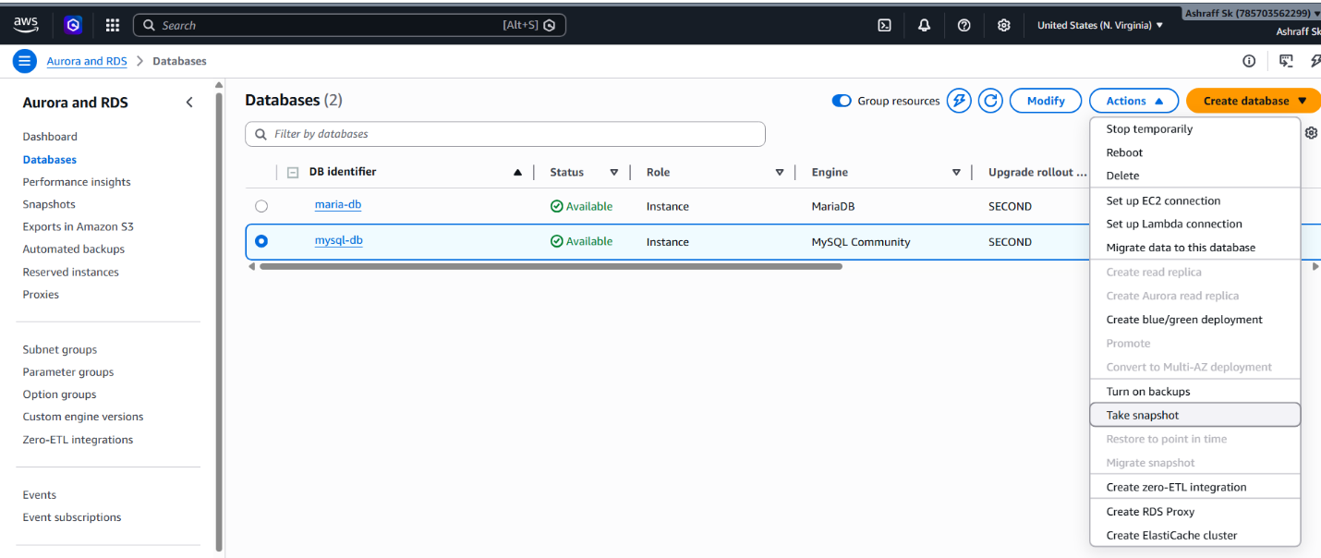
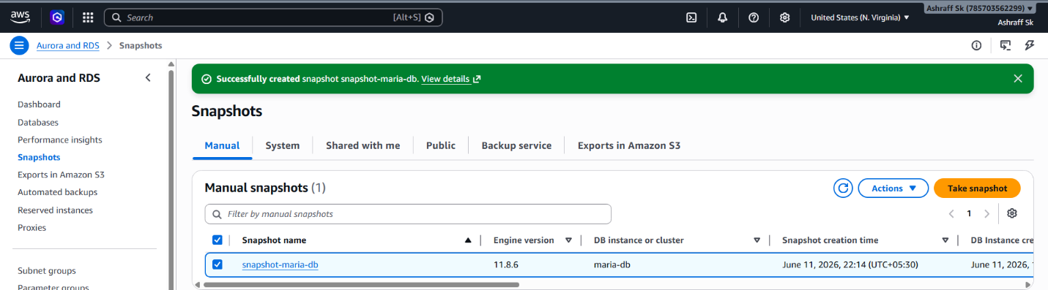
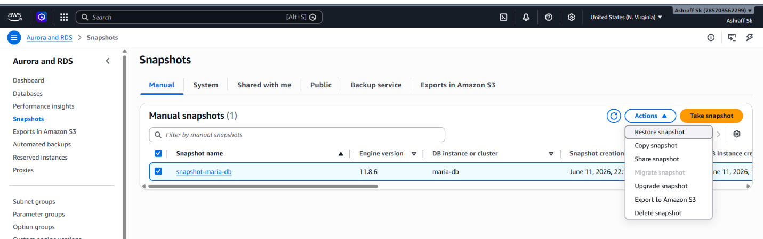
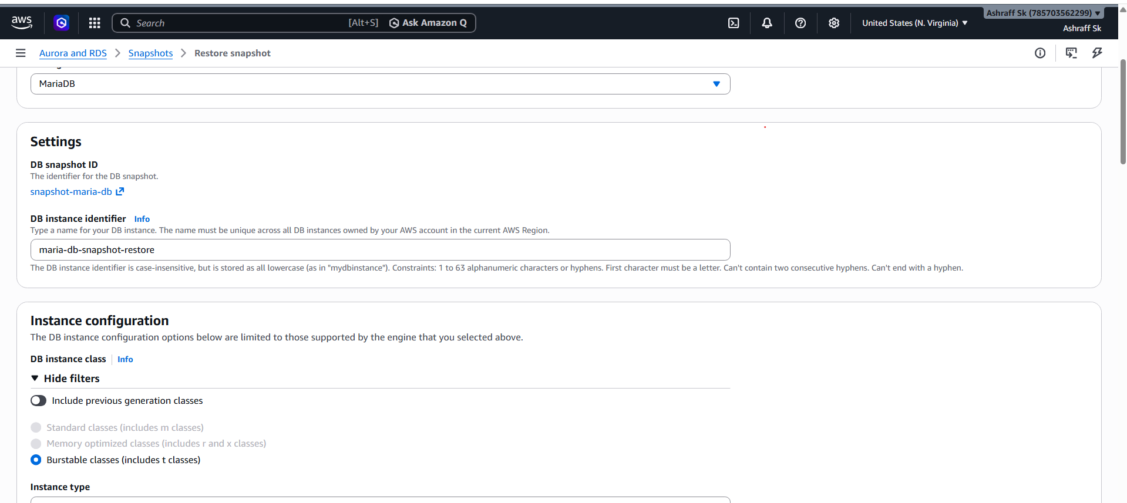
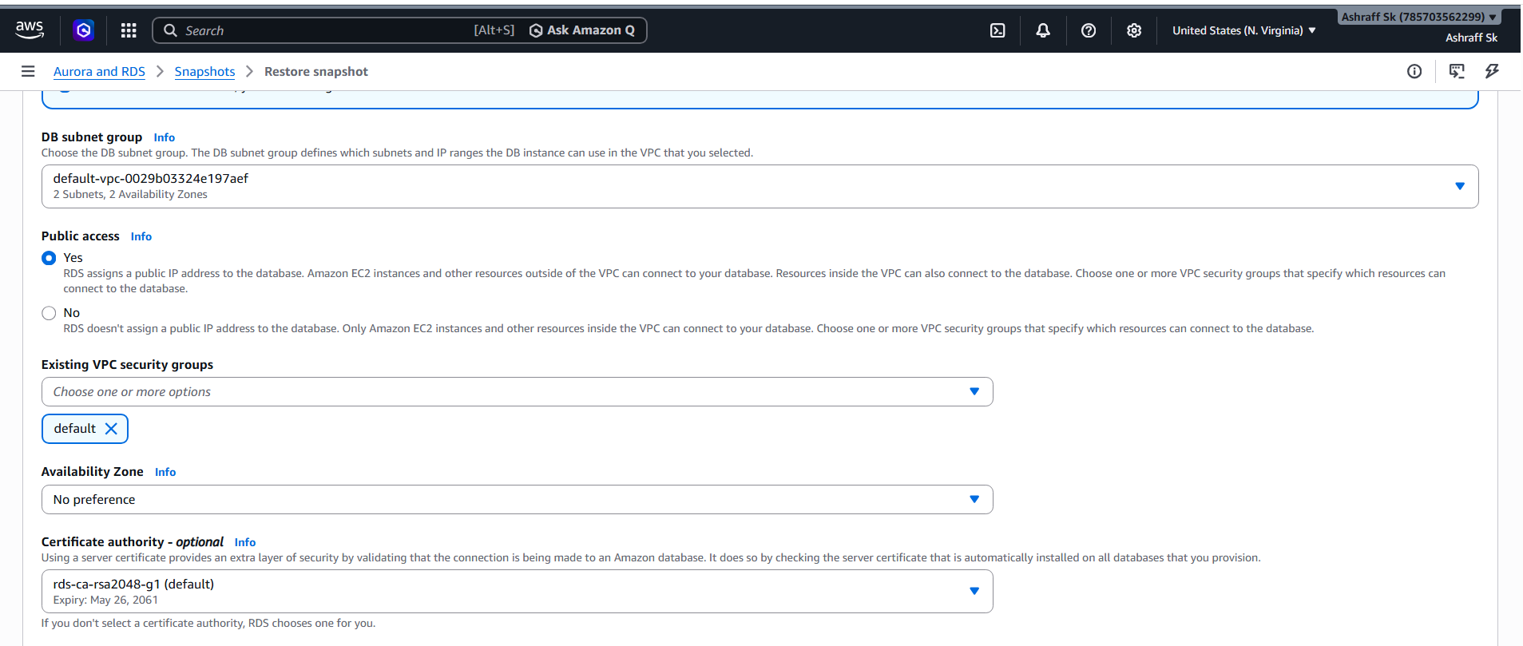
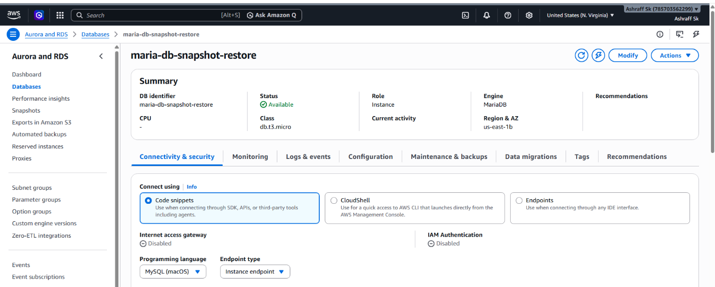
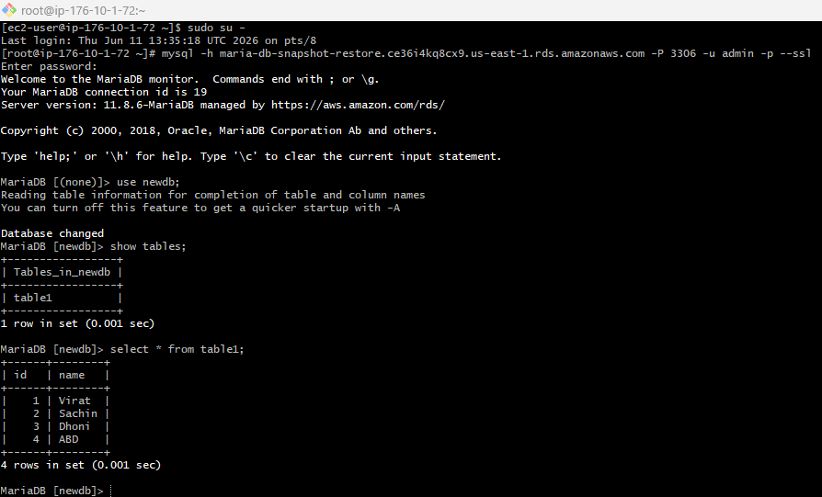
- Create read replica.

Objective
Create a Read Replica for the primary RDS database to improve read scalability and demonstrate replication.

Steps:
- Read replicas are copy of primary instance
- Read replica instance has only read access
- And it will be in other available zone
- Also used for backup of primary database
- It will be created in same region but in other subnet that has different zone
- Now under my database a new database has been created
- It is read replica database
- It has only read access
- I will check if the entire data in main database has been copied to RR or not
- I have created a new database in rds
- We can see it has been created in READ REPLICA database automatically
- In a similar way any data given into main database the entire data will be
replicated into the RR database
- The backup option has to enabled in the primary database to enable the read replica option.
